TECH SPARKLE



**Sparkgeist: Where Code Meets Genius**

Batch:60

Sadiya Bente Akter

University of Barishal

5,February 2025

**EXECUTIVE SUMMARY**

Tech Sparkle is an innovative technology firm that specializes in developing cutting-edge software solutions and hardware products aimed at enhancing productivity and efficiency in various industries. Established in [Year of Establishment], Tech Sparkle has quickly positioned itself as a leader in the tech sector by prioritizing research and development, customer satisfaction, and sustainable practices.



**Vision Statement:**

To empower businesses and individuals through innovative technology solutions that sparkle with creativity, performance, and reliability.



**Mission Statement:**

To deliver high-quality tech solutions that drive efficiency and innovation, while fostering a culture of teamwork, integrity, and excellence.

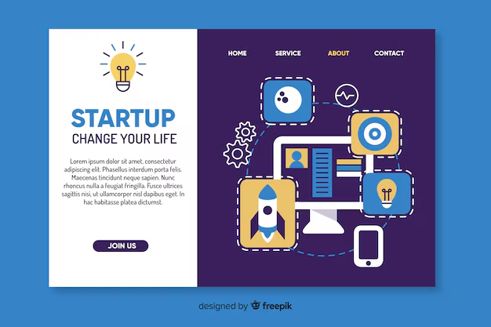

**Core Competencies:**

- Software Development: Custom applications, mobile apps, and enterprise solutions.

- IoT Solutions: Smart devices and integrations for enhanced connectivity.

- Cloud Services: Secure and scalable cloud infrastructure for businesses.

- Data Analytics: Advanced analytics tools for better decision-making.



**Market Position:**

Tech Sparkle serves a diverse clientele ranging from startups to large enterprises across various sectors including finance, healthcare, and education. With a growing market presence and a dedicated customer base, Tech Sparkle is continuously expanding its product offerings and geographic reach.

**Recent Achievements:**

- Launched [Product/Service Name] which received [specific accolade or recognition].

- Partnered with [notable company/organization] to enhance product offerings.

- Achieved [specific milestone, e.g., revenue growth percentage, market expansion].

**Future Outlook:**Tech Sparkle plans to launch several new products in the upcoming year focused on [insert specific areas, e.g., AI, machine learning]. The company is also looking at strategic partnerships to bolster its market presence and enhance product development.

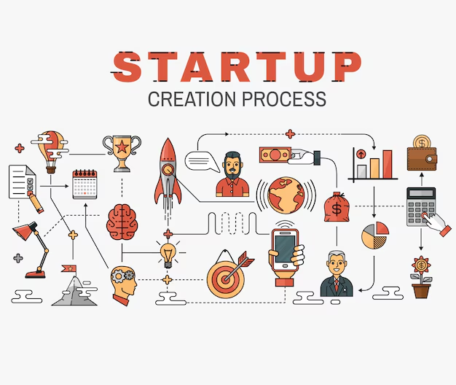

**Description**: This visual representation showcases the interconnectedness of Tech Sparkle's core areas of expertise—Software Development, IoT Solutions, Cloud Services, and Data Analytics. Each section is designed to reflect the dynamic and innovative spirit of the company, as well as its commitment to providing integrated solutions that meet diverse customer needs.

For a visual representation, you may want to use a circular or hexagonal design where each segment represents a different competency area of the company, along with icons symbolizing each sector. This can further emphasize Tech Sparkle's holistic approach to technology and innovation.

This executive summary is a concise overview of Tech Sparkle's key attributes, market positioning, and future goals, intended for stakeholders and potential investors.

Creating a comprehensive list of products and services for a company named "Tech Sparkle" involves understanding the potential focus areas for a tech-oriented business. Here’s a suggested breakdown:

Products

2. ** Hardware *

- **Smart Devices:** IoT products like smart home devices, wearables.

- **Custom PCs/Laptops:** High-performance machines tailored for gamers or professionals.

- **Tech Accessories:** Unique gadgets, charging stations, and ergonomic peripherals.

2.::*Tech kit*

- **DIY Kits:** For electronics enthusiasts (e.g., Raspberry Pi kits, Arduino projects).

- **Educational Kits:** STEM-focused kits for schools and students.

3. **Cloud Solutions:**

- **Cloud Storage Services:** Secure data storage solutions.

- **Cloud Computing:** Virtual machines, database services, and computing power.

### Services

1. **Consulting Services:**

- **Tech Consulting:** Advisory services for businesses looking to integrate technology.

- **Cybersecurity Consulting:** Assessing and improving security measures for companies.

2. **Development Services:**

- **Custom Software Development:** Tailored software solutions for businesses

- **Web Development:** Designing and building websites.

- **App Development:** Creating mobile apps for various platforms.

3. **IT Services:**

- **Managed IT Support:** Outsourced IT management for businesses.

- **Network Setup and Maintenance:** Support for installing and maintaining network infrastructure.

- **Data Backup and Recovery Services:** Solutions for data protection and recovery.

4. **Training and Workshops:**

- **Tech Training Programs:** Workshops on software, coding, and digital marketing.

- **Certification Courses:** Offering courses for various tech certifications (e.g., cloud, security).

5. **Maintenance Services:**

- **Hardware Repairs:** Device repair and maintenance services.

- **Software Updates:** Regular updates and maintenance for applications and systems.

6. **Digital Marketing Services:**

- **SEO and Content Marketing:** Services to improve online visibility.

- **Social Media Management:** Managing and strategizing social media presence.

7. **Research and Development:**

- **Innovation Labs:** Collaborating with clients for product development and testing new technologies.

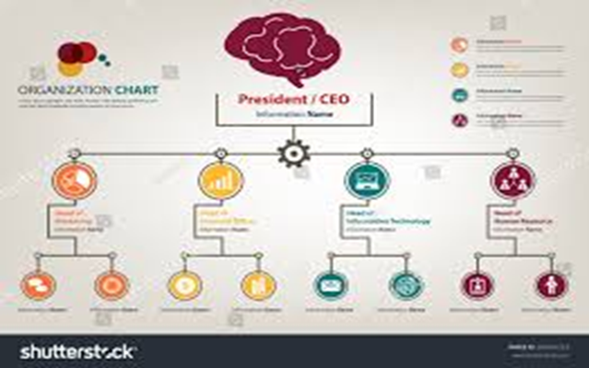

By focusing on these areas, Tech Sparkle can cater to a wide range of clients—from individuals wanting the latest tech products to businesses needing comprehensive tech solutions and support.

**MARKET ANALYSIS**

### 1. **Industry Overview**

- **Sector**: Technology, specifically focusing on consumer electronics, software solutions, or tech services.

- **Market Size**: Analyze the current size of the tech industry and its growth rate. A projected CAGR (Compound Annual Growth Rate) can provide insights into future potential.

- **Trends**: Emerging technologies such as AI, IoT, AR/VR, cloud computing, etc. Understanding which trends are gaining traction is crucial.

- **Regulatory Environment**: Consider any regulations that impact the tech industry, such as data protection laws, intellectual property rights, and trade regulations.

### 2. **Target Market**

- **Demographics**: Identify who the primary customers are (age, gender, income levels, etc.).

- **Geographics**: Determine the geographical locations where Tech Sparkle intends to market its products or services.

- **Psychographics**: Understand customer preferences, interests, and behaviors that drive purchasing decisions.

### 3. **Competitive Analysis**

- **Competitors**: List key competitors in the space (both direct and indirect) and analyze their strengths and weaknesses.

- **Market Share**: Estimate the market share of Tech Sparkle versus its competitors.

- **Positioning**: Define how Tech Sparkle differentiates itself in terms of pricing, technology, quality, and customer service.

### 4. **SWOT Analysis**

- **Strengths**: Unique technologies, strong R&D, excellent customer service, brand recognition, etc.

- **Weaknesses**: Limited resources, brand image challenges, narrow product range, etc.

- **Opportunities**: New market segments, international expansion, partnerships, technological advancements, etc.

- **Threats**: Intense competition, rapid technological changes, economic downturns, etc.

### 5. **Marketing Strategy**

- **Product or Service Offering**: Define what products or services Tech Sparkle offers and their unique selling propositions (USPs).

- **Pricing Strategy**: Establish how Tech Sparkle prices its offerings compared to competitors.

- **Distribution Channels**: Identify how products will reach customers (online, retail, direct sales, etc.).

- **Promotion**: Outline marketing and advertising strategies, including digital marketing, social media, content marketing, etc.

### 6. **Financial Projections**

- **Revenue Estimates**: Provide forecasts for revenue based on market trends and target market size.

- **Cost Analysis**: Break down expected costs, including R&D, marketing, staffing, and operational expenses.

- **Profitability**: Analyze potential profit margins and break-even analysis.

### 7. **Market Challenges**

- Address potential barriers to entry, such as high capital requirements, intense competition, and the need for constant innovation.

- Discuss how Tech Sparkle plans to address these challenges.